**Natural Language Processing (NLP)**

Link-https://www.kaggle.com/nitishputrevu/nlp-snli-dataset

Task1-To determine the inference relationship namely,*entailment, contradiction, or neutral*(SNLI), between the sentence pairs

Steps-

1)Loaded the json files in three variables-train test and dev

2)Dropped sentence pairs from train test and dev which has no tags determining the inference relationship (gold labels).

3)Introduced dictionaries-training_X, testing_X and dev_X which contained both the sentence pairs

4)Introduced lists called training_Y, testing_Y and dev_Y which contained manually encoded representations of the inference relationship between the sentence pairs

*(Entailment-[100000000000000], Contradiction-[010000000000000],  Neutral-[001000000000000]*

*5)Tokenised and padded (post truncation with maxlength 50) each sentence present in the sentence pairs and then represented one sentence pair as the difference between the 2 pairs*

*6)Introduced the model I have used-BIDICTIONAL LSTM*

model = tf.keras.Sequential([

tf.keras.layers.Embedding(1000, 16, input_length=50),

tf.keras.layers.Bidirectional(tf.keras.layers.LSTM(32,input_shape=(549367,50),recurrent_dropout=0.2,return_sequences=True)),

tf.keras.layers.Flatten(),

tf.keras.layers.Dense(24, activation='relu'),

tf.keras.layers.Dense(4, activation='softmax')

])

model.compile(loss='sparse_categorical_crossentropy',optimizer='adam',metrics=['accuracy'])

7)After fitting,using validation data (dev_X and dev_Y),measured accuracy using test data and hence predicted the inference relationship between the sentence pairs

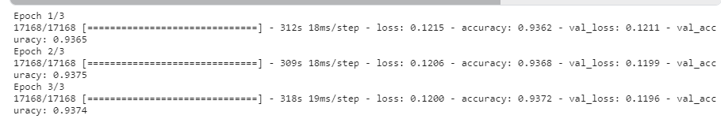

Results-

Task2-

1. Introduced a variable-tagged_sentence which contains sentences with tags from the nltk.corpus.treebank.tagged_sents(tagset='universal')
2. Separated the sentences and tags in two separate lists N1_X and N1_Y respectively
3. Introduced list called num_N1_Y which contained manually encoded representations of the inference relationship between the sentence pairs
4. *(*1-. 2-ADJ', 3-'ADP', 4-'ADV', 5-'CONJ', 6-'DET', 7-'NOUN', 8-'NUM', 9-'PRON', 10-'PRT', 11-'VERB', 12-'X'*)*
5. *Used train test split and obtained data for variables train_X, validation_X(N1_X), train_Y and validation_Y(Num_N1_Y)*
6. *Fitted the data using the same model and obtained predictions of sentences*

*Observations-Acuracy of 75,55% was obtained showing that the model does predict inputs to a certain extent based on parts of speech.*